**Project Management**

Assessment Two

Full Name: IRNANDI MULIAWAN Student ID: 18073

Wells international college

|  |  |  |  |
| --- | --- | --- | --- |
| Name of Student | IRNANDI MULIAWAN | ID | 18073 |

**Assessment 2 – Research (Online)**

Contents

Instructions: 1

Duration: 1

Multiple-choice Questions: 2

Learning Notes: 7

What is project? 7

Please put your learning notes here: 8

Project management basic 8

Project management History 8

Project management in the future 8

Document Search Index 8

## Instructions:

This is an individual assessment. Answer all the questions on the document provided by your Trainer.

## Duration:

Trainer will set the duration of the assessment.

## Multiple-choice Questions:

1. 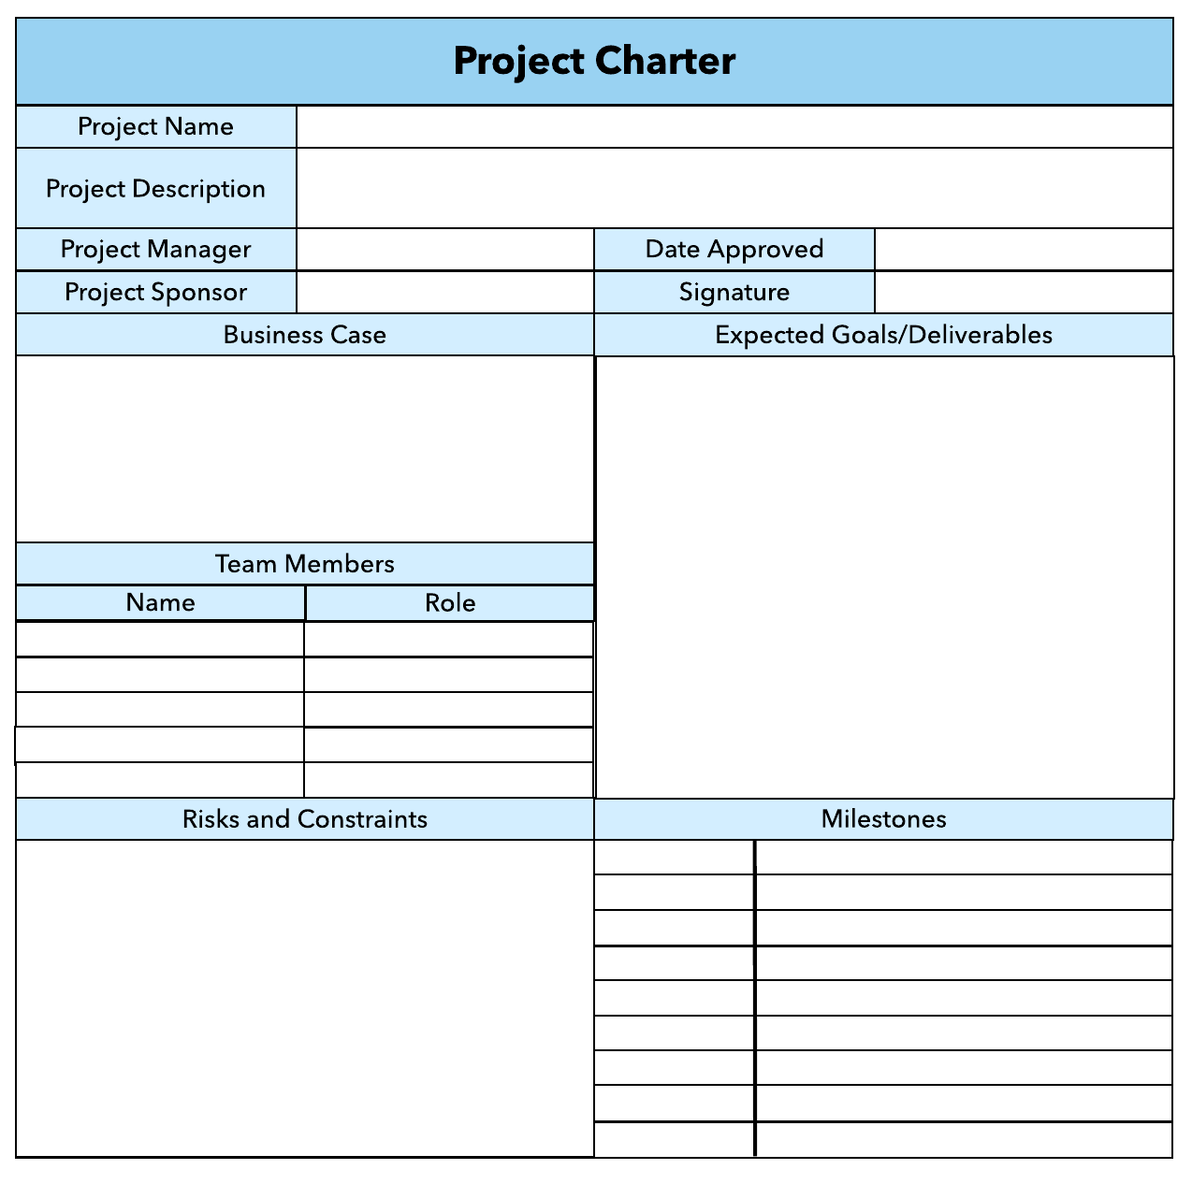What advice do we give about factoring in the commitments of project stakeholders when making your own plans?
   1. Consult student timetables to see when they might be free to attend data collection sessions.
   2. Ask external organizations what the most convenient times would be for you to visit
   3. Neither of these

d) Both A and B

Comment: your plan needs your stakeholders know before implantation.

1. Which of the following are essential components of a GANTT chart used to plan your project?
   1. Your home telephone number
   2. Your supervisor’s home telephone number
   3. The email address for the chair of the ethics committee
   4. None of the above

Comment: in order to get right or good Gantt Char, you need keep concern time, cost, scope and quality. So will get the good requirement and write good Gantt Char

Web ref: <https://www.proofhub.com/articles/gantt-charts>

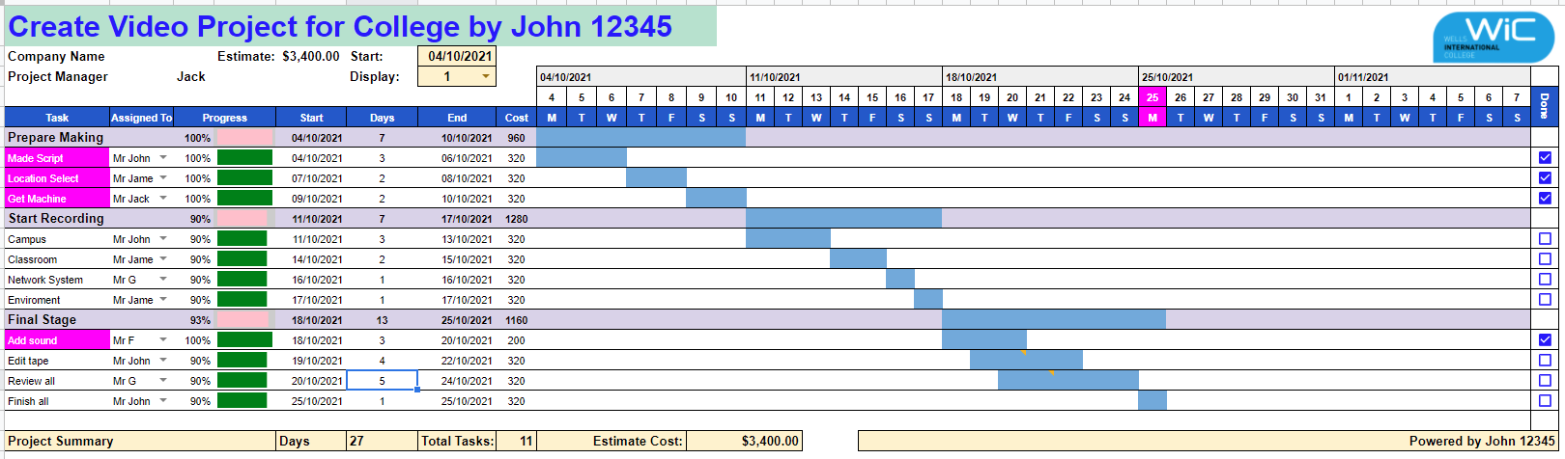

1. The intended outcome of strategy/projects integration is
   1. Clear organization focus
   2. Best use of scarce organization resources
   3. Improved communication across projects and departments
   4. Both A and C are correct
   5. A, B, and C are all correct

Comment: A generic methodology that ensures integration by creating very strong linkages of projectselection and priority to the strategic plan is then discussed. The intended outcomes are clearorganization focus, best use of scarce organization resources (people, equipment, capital), andimproved communication across projects and departments



Comment: **Integration** management is a collection of processes required to ensure that the various elements of the **projects** are properly coordinated. It involves making trade-offs among competing objectives and alternatives to meet or exceed stakeholder needs and expectations.

Web Refer: <https://en.m.wikibooks.org/wiki/Project_Management/PMBOK/Integration_Management>

1. Which of the following questions does the organization's mission statement answer?
   1. What are our long-term strategies?
   2. What are our long-term goals and objectives?
   3. How do we operate in the existing environment?
   4. What do we want to become?
   5. All of these are answered by the mission statement

Comment :

mission statement directly relates to the vision by articulating the greater reason why that vision matters. A powerful mission keeps the organization on track and rallies around the direction the organization is headed

Source : <https://onstrategyhq.com/resources/mission-statements/#:~:text=The%20definition%20of%20a%20mission,you%20do%20what%20you%20do.>

1. Which of the following is not one of the requirements for successful implementation of strategies through projects?
   1. Allocation of resources
   2. Prioritizing of projects
   3. Motivation of project contributors
   4. Adequate planning and control systems
   5. All of these are requirements

Comment :

Strategy implementation is the stage that demands participation of the entire organization. Formulation of the strategies are mostly in the hands of the strategic management team, with the aid of senior management and key employees. When it comes to implementation, however, it is the workforce that will execute the strategic plan, with top or senior management taking the lead.

Source: <https://www.cleverism.com/strategy-implementation-process/>

1. Which of the following is the reason(s) why project managers need to understand their organization's mission and strategy?
   1. To make appropriate decisions and adjustments
   2. To be effective project advocates
   3. To be able to get their job done
   4. Both A and B are correct
   5. A, B, and C are all correct

Comment : There are 2 main reasons as to why project managers need to understand their organisation’s mission and strategy.

• The first reason is that:

- So, that the project managers can make appropriate decisions and adjustments, when responding to changes. - For example, how a project manager would respond to a suggestion to modify the design of a product to enhance performance will vary depending on whether his company strives to a product leader through innovation, or to achieve operational excellence through low-cost solutions.

• The second reason is that:

- Project managers need to understand their organisation’s strategy is so they can be effective project advocates, aligned with the firm’s mission. - For example, even during difficult times such as the changing of ownership.

Source: <https://s3.studentvip.com.au/notes/16149-sample.pdf>

1. Which of these is the highest priority and first strategy required for any organizational change?

a) Communication

* 1. Stress management
  2. Negotiation
  3. Learning
  4. Employee involvement

Comment :  
The highest priority and first strategy required for any organizational change is to:  
alter the responsibilities of senior executives in the organization. introduce stress management counseling to the employees.train employees who do not possess the skills required under the new conditions. Communicate the need for change and keep employees informed about what they can expect from the change effort. negotiate a new set of relations among those who will clearly lose out from the change. **Communication** is the highest priority and first strategy required for any organizational change

Source: <https://www.coursehero.com/file/p75kuie/The-highest-priority-and-first-strategy-required-for-any-organizational-change/>

1. Which of the following is not a procedure to obtain an understanding risk in the planning stage (described in ISA 315):
   1. Inquiries of management
   2. Analytical procedures
   3. Observation and inspection
   4. Procedures for sampling audit tests

Comment : Procedures for sampling audit test are the standard in ‘Understanding the Entity and Its Environment and Assessing the Risks of Material Misstatement’ not for planning stage

Source: <https://www.iasplus.com/en-ca/projects/assurance/completed-projects/iaasb-revisions-to-isa-315-identifying-and-assessing-the-risks-of-material-misstatement-through-understanding-the-entity-and-its-environment-research>

1. Assessment of control risk includes three steps. Which of the following is not one of these steps?
   1. Obtaining an understanding of internal controls and documentation of the controls
   2. Evaluate sufficiency and appropriateness of audit evidence
   3. An initial assessment and response to assessed risk based on the design of internal controls resulting in an audit planning memorandum and audit plan
   4. A final assessment based upon test of controls of operating effectiveness

Comment : There are three steps used to manage health and safety at work.

Spot the Hazard (Hazard Identification)

Assess the Risk (Risk Assessment)

Make the Changes (Risk Control)

Source: <https://www.education.vic.gov.au/school/students/beyond/Pages/hazidentify.aspx>

1. Which of the following are not common internal control documentation techniques used by auditors?

a) Questionnaires

* 1. Company internal control manuals
  2. Narrative descriptions
  3. Check lists

Comment : The main job of an internal auditor (IA) is to identify problems and correct them before they are discovered during an external audit by an outside firm or regulatory agencies, such as the [Securities and Exchange Commission](https://www.investopedia.com/articles/investing/112914/understanding-sec.asp) (SEC). One of the roles of the SEC is to regulate how companies report their financial statements to help ensure that investors have access to all of the necessary information before investing. Therefore, auditors never take any company internal control manuals since they have to assess by themselves first.

Source: <https://www.investopedia.com/terms/i/internalauditor.asp>

1. Overall response to assessed risk may include:
   1. Identify the absence of key controls (where controls are lacking)
   2. Identify existing controls
   3. Incorporating additional elements of unpredictability in the selection of further audit procedures to be performed
   4. Determine potential material misstatements that could result

Comment : The auditor's responses to the assessed risks of material misstatement, particularly fraud risks, should involve the application of professional skepticism in gathering and evaluating audit evidence

Source: <https://pcaobus.org/oversight/standards/auditing-standards/details/AS2301#:~:text=The%20auditor%27s%20responses%20to%20the%20assessed%20risks%20of%20material%20misstatement,gathering%20and%20evaluating%20audit%20evidence.>

1. 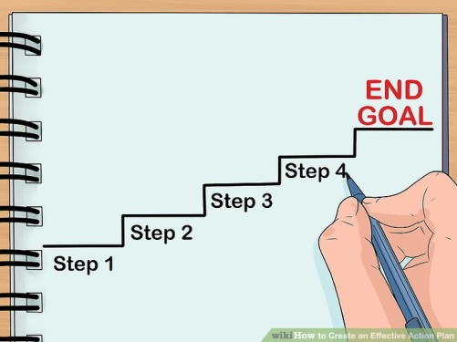Action plan Should be
   1. Specific
   2. Countable
   3. Realistic
   4. Achievable

Comment: An **action plan** is a detailed **plan** outlining actions needed to reach one or more goals. Alternatively, businessdictionary.com defines an **action plan** as a "sequence of steps that must be taken, or activities that must be performed well, for a strategy to succeed".

Web Refer: <https://en.wikipedia.org/wiki/Action_plan>

1. Which of the following is not a function of Project Management Tool?
   1. Plan a project
   2. Manage Tasks
   3. Manage Issues
   4. Time Tracking
   5. Non of above

Comment : Project management tools are a set of software designed to help project teams to plan a project, track & manage the projects to achieve the defined project goals. It also helps team members to collaborate effectively and accelerate the projects to meet the specified constraints.

Source: <https://www.wrike.com/project-management-guide/faq/what-are-project-management-tools/>

1. John, the project manager for the ERP Project, is about to complete the project phase review. The completion of a project phase is also known as which of the following? a) A lesson learned
   1. A kill point
   2. Earned value management
   3. Conditional advancement

Comment : The completion of a project phase may also be known as a kill point. Lessons learned is a collection of information and knowledge gained through an experience, typically a phase, within the project.

Source: <https://www.invensislearning.com/blog/5-phases-project-management-lifecycle/>

1. Which of the following is not a key stakeholder in a project that creates a service internal to an organization?
   1. The project manager
   2. External customers
   3. Project vendors
   4. Project team members

Comment : External customers are not key stakeholders in this instance as they are not actively involved in an internal project.

Source: <https://quizlet.com/13988866/pmp-questions-flash-cards/#:~:text=External%20customers%20are%20not%20key,involved%20in%20an%20internal%20project.>

1. Managing a project is best described as which one of the following?
   1. Establishing direction
   2. Functional controls over the project team and stakeholders
   3. Consistently producing key results expected by stakeholders
   4. Motivating and inspiring the project team to produce results that are expected by project stakeholders

Comment : Managing has to do with consistently producing key results that are expected by stakeholders.  
Choices A and D describe the leadership processes a roject manager must possess, therefore they are wrong.  
Choice B is incorrect as it describes the functional management position over project team members.

1. You are the project manager for your organization. Influencing your organization requires which of the following?
   1. An understanding of the organizational budget
   2. Research and documentation of proven business cases
   3. An understanding of formal and informal organizational structures
   4. Positional power

Comment : To influence an organization (to get things done), a project manager must understand the explicit and implied organizational structures within an organization.  
A is incorrect, since the project manager may not even have access to an organizational budget. B is incorrect because a proven business case may not map to every scenario when influencing an organization. Finally, D is incorrect because positional power may relate only to a small portion of an organization, not to multiple facets of influence.

1. What is the difference between a standard and a regulation?
   1. Standards are mandatory; regulations are not.
   2. Standards are optional; regulations are not.
   3. Regulations and standards are essentially the same.
   4. Regulations are usually mandatory; standards may be seen as guidelines.

Comment :  
A Standard is a “document established by consensus and approved by a recognized body that provides, for common and repeated use, rules, guidelines or characteristics for activities or their results, aimed at achievement of the optimum degree of order in a given context.”

A Regulation “is a government imposed requirement, which specifies product, process or service characteristics, including the applicable administrative provision, with which compliance is mandatory. Building codes are an example of regulations.”

Therefore, option B is correct

Source: <https://www.riskandresiliencehub.com/do-you-know-the-difference-between-standards-and-regulations/>

1. Which of the following is an example of a deliverable at the end of the requirements-gathering phase in a software design project?
   1. Responsibility matrix creation
   2. Detail design document
   3. Business needs
   4. Project team assembled

Comment : Choice **A** is incorrect because the responsibility matrix creation is a process, not an output of itself. **C** is incorrect because business needs may prompt the project to begin, not an output of a phase. **D** is also wrong because the project team assembled is part of the project process; it is not an output.therefore the answer is B

1. At what point in a project would a kill point be acceptable?
   1. When a project team member is not performing as planned
   2. When a project reaches the end of a project phase
   3. When a project reaches the end of its budget
   4. When a project manager determines the project team cannot continue

Comment : Kill points are typically at the end of a project phase. A kill point does not mean the project is killed, just that the potential for termination exists.

1. Of the following, which is not an exit criterion?
   1. Customer sign-offs
   2. Quality metrics
   3. Stakeholder analysis
   4. Regulatory inspections

Comment : Exit criterion are activities or evidence that allow a project to move forward. Stakeholder expectations are universal to the entire project, not just to one project phase. Choices A, B, and D are all examples of activities that can be considered exit criteria.

1. At which point is the risk of failure the least but the consequence of failure the highest?

a) During the early stages

* 1. During the middle stages
  2. During the final stages
  3. Risk of failure is even across all project phases

Comment : As the project moves closer to completion, the likelihood of risk diminishes.

1. In project estimation, project manager has to provide an expert judgement, which are considered of the following EXCEPT:
   1. Impact of inflation over the project lifecycle
   2. Required labour and labour rates
   3. Material costs and assumptions
   4. Costs of quality
   5. All of above
   6. None of above

Comment : none of the option from a to e are describing an expert judgment

1. Which component is/are included in Quality Management Plan
   1. Quality objectives
   2. Key project deliverables
   3. Quality standards
   4. Quality control and assurance activities
   5. All of above

Comment :The four main components of a quality management process are Quality Planning, Quality Assurance, Quality Control and Continuous Improvement.

Source: <https://www.parallelprojecttraining.com/blog/describe-the-four-main-components-of-a-quality-management-process/#:~:text=The%20four%20main%20components%20of%20a%20quality%20management%20process%20are,Quality%20Control%20and%20Continuous%20Improvement.>

1. What's an activity sequencing
   1. 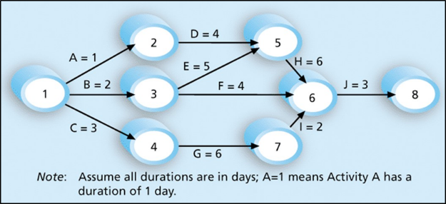The process for identifying and documenting dependencies among schedule activities
   2. The process for identifying critical activities
   3. The process for identifying ordering and schedule activities
   4. The process for planning the project

***Activity sequencing*** reviews all activities in the WBS with the goal of identifying relationships between them and classifying all the timing relationships among tasks. These relationships (aka "linkages", "dependencies", "predecessors"). Task timing relationships are important because they control task sequencing and task start and end dates. There are four types of task relationships:  
A ***finish-to-start relationship***

A ***start-to-start relationship***

A ***finish-to-finish relationship***

A***start-to-finish relationship***

Refer: <https://www.e-education.psu.edu/geog871/l5_p4.html>

Comment: activity sequencing could help make your project stage very clear and easy to follow the project progress. The process for identifying and documenting dependencies among schedule activities

## Learning Notes:

<https://www.youtube.com/watch?v=rBSCvPYGnTc&t=1323s>

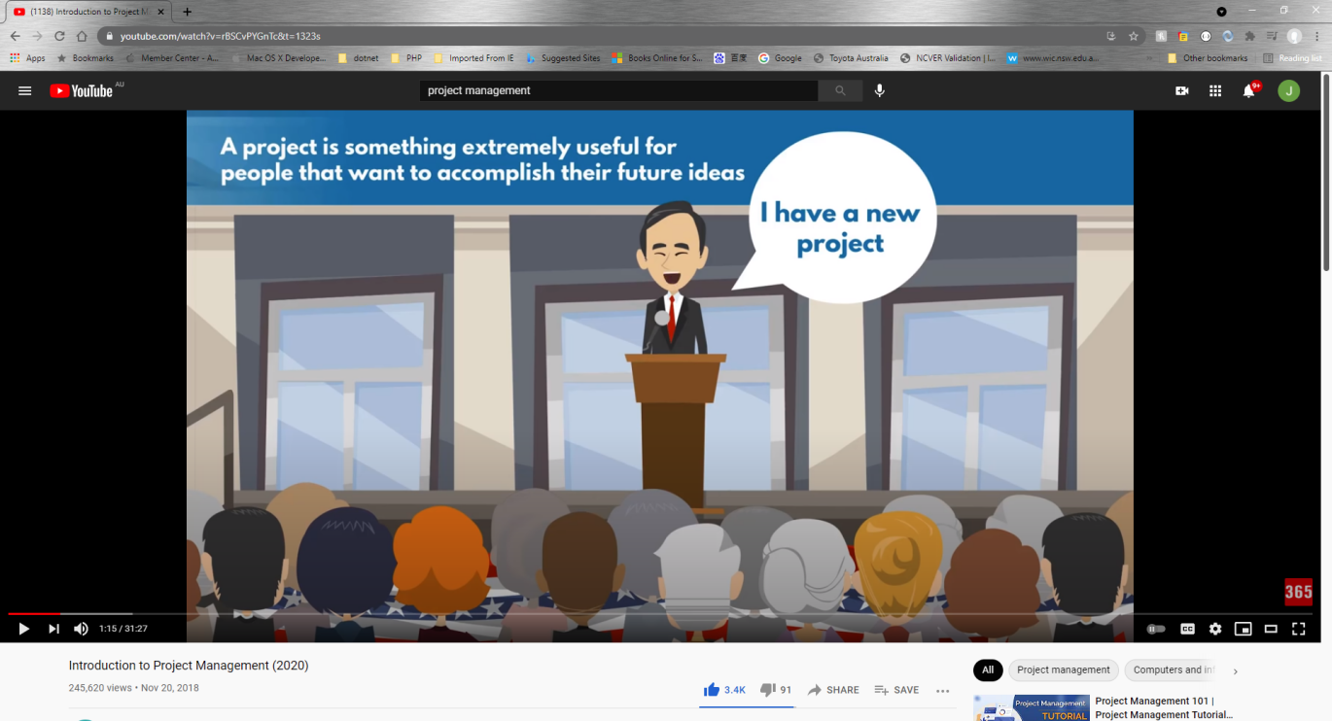

## What is project?

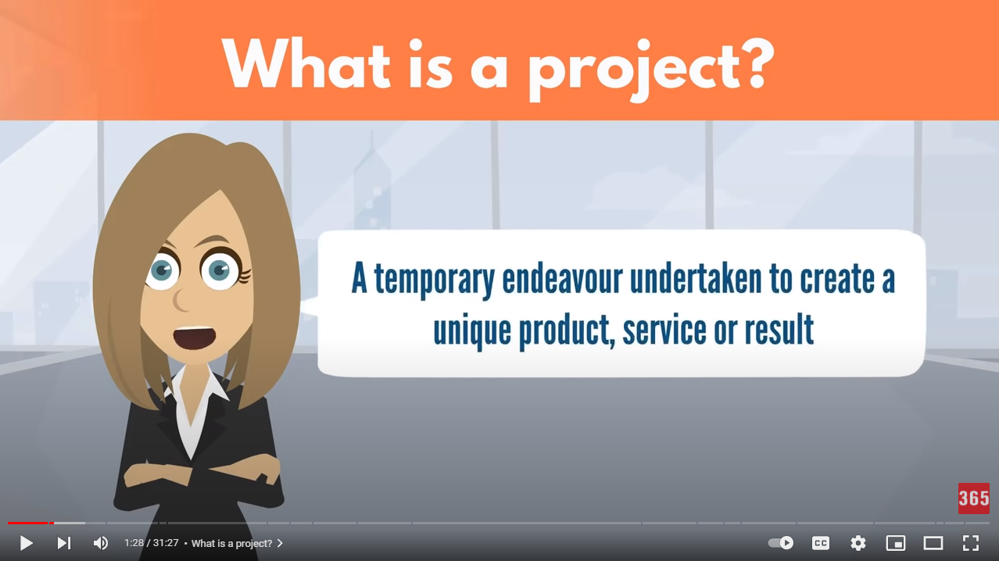

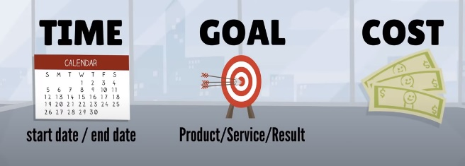project need you make a big effect in order to achieve a unique or specific goal…

project need show start date or time and finish date or time

## Please put your learning notes here:

## Project management basic

Project management focuses on planning and organizing a project and its resources. This includes identifying and managing the lifecycle to be used, applying it to the user-centered design process, formulating the project team, and efficiently guiding the team through all phases until project completion.

Source:

<https://www.usability.gov/what-and-why/project-management.html#:~:text=Project%20management%20focuses%20on%20planning,all%20phases%20until%20project%20completion.>

## Project management History

Project management has been practiced for thousands of years since the Egyptian era, however, it has been about half a century ago that organizations start applying systematic project management tools and techniques to complex projects. In the 1950s, Navy employed modern project management methodologies in their Polaris project. During the 1960s and 1970s, Department of Defense, NASA, and large engineering and construction companies utilized project management principles and tools to manage large budget, schedule-driven projects. In the 1980s, manufacturing and software development sectors started to adopt and implement sophisticated project management practices. By the 1990s, the project management theories, tools, and techniques were widely received by different industries and organizations

Source : https://home.gwu.edu/~kwak/PM_History.pdf

## Project management in the future

In this milestone 50th year for the Project Management Institute it’s natural to want to look back at the significant trends have shaped the project management profession over the last five decades, namely globalization of the discipline, and the explosion of methods, techniques and practices being applied to projects. Looking ahead, new trends continue to emerge, however many of these are already having a dramatic impact on the way that project managers go about their work.

1) Artificial Intelligence (AI)

2) Organizational project management

3) Virtual project teams

4) Methodologies

5) Emotional intelligence

6) Lifelong learning

7) Project managers in demand

Source: <https://www.liquidplanner.com/blog/seven-future-trends-in-project-management/>

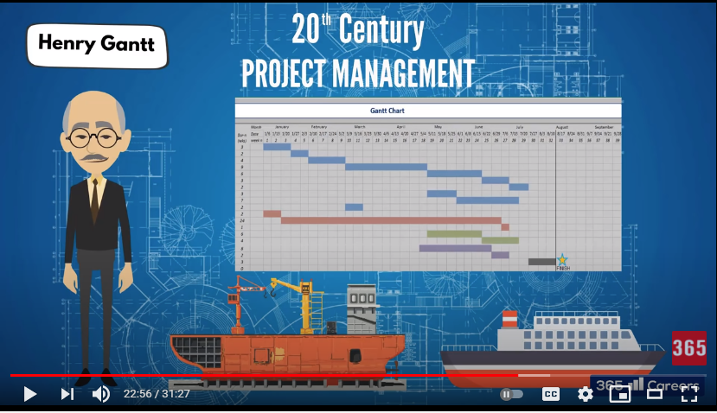

## Document Search Index

A

a GANTT chart 2

M

mission and strategy 3

mission statement 3

O

organizational change 3

P

project stakeholders 2

projects integration 2

S

successful implementation 3

U

understanding risk 4